Deep Learning-Based Handwritten Table Detection and Optical Character Recognition for Automated Document Digitization

1. Background

1.1 Introduction and Motivation
Educational institutions, examination boards, and administrative organizations continue to rely heavily on handwritten tabular documents such as marksheets, attendance registers, examination top sheets, and result sheets. Managing these documents manually is time-consuming, prone to transcription errors, and difficult to archive efficiently. Automatic digitization of handwritten tables using computer vision and Optical Character Recognition (OCR) can significantly reduce manual effort while improving data accuracy and accessibility. Recent advances in deep learning-based document analysis provide an opportunity to automate the extraction of structured information from scanned handwritten documents.

1.2 Problem Statement
Although OCR technology has achieved high accuracy on printed documents, handwritten tabular documents remain challenging due to irregular handwriting, varying table layouts, broken or missing table borders, skewed document images, and inconsistent lighting conditions. Existing OCR systems often fail to correctly detect table structures and accurately recognize handwritten cell contents, resulting in incomplete or incorrect digitization.

1.3 Gaps and Limitations in Existing Work
Existing handwritten document digitization methods primarily focus either on handwriting recognition or table structure detection, with limited integration of both tasks into a unified pipeline. Traditional image processing techniques rely heavily on handcrafted rules that are sensitive to image quality and table variations. Furthermore, many existing approaches struggle with partially visible borders, merged cells, handwritten annotations, and noisy scanned documents, reducing their applicability in real-world academic environments.

1.4 Objectives
- Develop an automated pipeline for handwritten table detection and document digitization.
- Detect table structures accurately from scanned handwritten documents using deep learning and computer vision techniques.
- Segment individual table cells for structured information extraction.
- Recognize handwritten text within each detected cell using an OCR model.
- Convert extracted information into structured JSON and spreadsheet formats.

2. Proposed Methodology
Figure 1 illustrates the complete document digitization pipeline, from scanned document acquisition through preprocessing, table detection, OCR, and structured data generation.
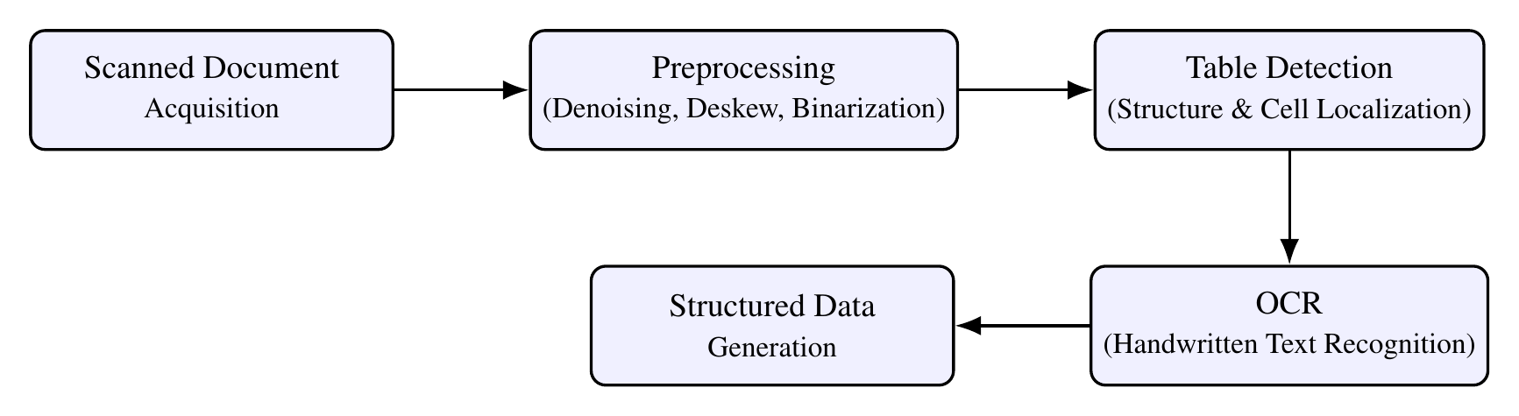
Figure 1. Overall pipeline for handwritten table detection and OCR-based digitization.

2.1 Dataset Collection
Primary Data
- Scanned examination top sheets
- Handwritten marksheets
- Academic record forms
- Handwritten tabular documents collected from educational institutions
Annotations
- Table boundary annotations
- Row and column structure annotations
- Cell-level bounding boxes
- Ground-truth handwritten text for OCR evaluation

2.2 Preprocessing
Image Enhancement
- Grayscale conversion
- Noise removal
- Contrast enhancement
- Adaptive thresholding
Geometric Correction
- Skew detection and correction
- Perspective transformation
- Image normalization
Table Enhancement
- Morphological operations
- Line enhancement
- Border reconstruction
- Removal of scanning artifacts
Data Augmentation
- Random rotations
- Scaling
- Brightness and contrast variation
- Gaussian noise
- Blur simulation

2.3 Modeling and Training

Table Detection
Train a deep learning-based object detection model (e.g., YOLOv8) to detect complete table regions from scanned handwritten documents.

Table Structure Recognition
Apply image processing and structural analysis techniques to identify:
- Rows
- Columns
- Individual cells
For documents with broken borders, integrate line reconstruction techniques to improve table segmentation.

Handwritten Text Recognition
Recognize handwritten cell contents using a transformer-based OCR model such as TrOCR.

Structured Data Generation
Combine detected table structures and OCR outputs to reconstruct the complete table and export the extracted information into structured formats including JSON and Excel.

2.4 Testing and Validation
Split the dataset into:
- 70% Training
- 15% Validation
- 15% Testing
Evaluate the proposed system using:

Table Detection
- Precision
- Recall
- Mean Average Precision (mAP)
- Intersection over Union (IoU)

OCR Performance
- Character Error Rate (CER)
- Word Error Rate (WER)
- Recognition Accuracy

End-to-End Evaluation
- Cell Detection Accuracy
- Table Reconstruction Accuracy
- Processing Time per Document

3. Expected Outcome
- A complete automated system for handwritten table detection and digitization.
- Accurate detection of handwritten table structures even under challenging document conditions.
- Reliable handwritten text recognition from individual table cells.
- Automatic generation of structured JSON and Excel files.
- A benchmark annotated dataset of handwritten tabular documents for future research.
- A scalable solution applicable to educational institutions and document management systems.

4. Conclusion
Digitizing handwritten tabular documents remains a significant challenge due to variations in handwriting, document quality, and complex table layouts. This research proposes an end-to-end deep learning pipeline integrating table detection, table structure recognition, and handwritten OCR for accurate document digitization. By combining modern object detection models with transformer-based handwriting recognition, the proposed system aims to reduce manual data entry, improve document accessibility, and provide a practical solution for educational and administrative record management.

References

- Computer Vision-Based Framework for Data Extraction From Heterogeneous Financial Tables: A Comprehensive Approach to Unlocking Financial Insights
- Automated Evaluation of Handwritten Answer Script Using Deep Learning Approach
- Digitization of Document and Information Extraction using OCR

https://drive.google.com/drive/folders/1mrBfQ36yMPj4ja7N_P4ccHQftX_cPyu9?usp=drive_link

